Assessment of Drying Characteristics and Empirical Modeling of Ginger by Different Drying Techniques
Abstract: Fruits and vegetables are perishable; they don’t have shelf life. They contain so much water that their logistic become difficult. Drying is both heat and mass exchange energy activity, mainly utilized as a food preservation technique. Fresh collected ginger was effectively dried from starting moisture content of 86% (w.b.) to the safe storage moisture content of 13% - 14% (w.b.) in open sun drying (OSD) and hot air oven solar dryers. It was found that hot air dryer of glass to glass module took less time (8hrs as compared to hot air dryer of opaque module (10hrs) and open sun drying (OSD) (14hrs). Drying behavior of ginger slices was analyzed during various mathematical models. Page model explains the drying behavior of ginger precisely with maximum values of coefficient of determination (R²) i.e. 0.996, 0.997 and 0.994 for hot air dryer of glass to glass module, opaque module and OSD respectively, and this model has minimum reduced chi-square, mean bias error and root mean square error.
Keywords: Ginger, moisture content, open sun drying (OSD), Solar hot air dryer, mathematical modeling.

- Introduction
Drying is a significant activity in ginger handling. In numerous spots all through the world, ginger is generally dried under open sun drying (OSD) condition (specifically, open environment). The OSD technique unfavorably influences the item quality as far as shading, sustenance, substance creation, and food cleanliness [1]. For the food preservation OSD is the best traditional method rehearsed in numerous metropolitan and provincial territories of agricultural nations. The significant drawback of open sun drying is bad quality of the item. The item gets defiled from dust, creepy crawlies, and different creatures which truly corrupt the quality of the food and its impact of the price [2]. In India, more than 300 days are clear and sunshiny and hypothetical solar oriented power gathering, on its territory region, is around five trillion kWh/year. The day by day normal solar oriented energy incident over India fluctuates from 5 to 7kWh/m² with around 1500 to 2000 daylight hours every year relying on the spot, which is definitely more than present energy utilization [3]. The examination shows that cost of drying with sun power is only 33% when contrasted with the cost utilizing a dryer based on conventional fuels [4]. These solar dryer take into account managed drying by dealing with the drying such as dampness content, temperature of air, stickiness, and wind speed. Sufficient drying assists with protecting the flavor, surface, also, shade of the food, which prompts a superior quality item [5]. Zingiberaceae family utilized the Ginger as a zest and home-grown medicine. It can be acquired around the world in its new or semi processed structure. With the expanding attention to the relationship between dietary phytochemicals and human wellbeing and prosperity, flavors and culinary spices have acquired the consideration of established researchers since they contain synthetic mixes that have cancer prevention agents what's more, restorative properties [6].
The region under the development in India is 108.6 thousand hectors and the complete creation of the nation is 517.8 thousand tons [7]. Ginger have many applications arrangement, pastry shop items, toiletry items, scent businesses, meat items, wine, and soda pops making. Dried ginger is utilized both as a zest and medication. In Ayurveda, it is term edas a significant medication to fix numerous illnesses, for example, ailment, throat issues, heaps, alcoholic gastritis, cholera morbus, texture illness, neuralgia, and aspiratory and catarrhal sicknesses [8]. The nature of ginger created in India has high substance of smell and sharpness what's more, it is likewise natural. Be that as it may, because of ill-advised postharvest handling the greater part of the ginger is to be burned-through as a new vegetable and furthermore a portion of the great characteristics, for example, visual offer, surface, smell, flavor, design, and shade of the material get influenced. A few investigations have been accounted for on an assortment of sunlight based dryers for drying grains, vegetables, and various natural products [9].Reenactment models are extremely useful in planning a new dryer or in improving a current dryer for the drying of horticultural items. Numerous specialists have conveyed out the examinations on the numerical displaying and trial concentrates on slight layer drying marvel of different items, as shown in Table 1.
Table 1: Literature study of thin layer drying of crops
S. No. | Author | Year | Crop | Method | Best model | Reference
1. | Fudholi, A., &Hidayati, S. | 2020 | Seaweed | Indirect type forced convection | Modified page model | [10]
2. | Nukulwar, M. R., &Tungikar, V. B. | 2020 | Turmeric | Indirect natural convection solar dryer (INCSD) and OSD | Page model | [11]
3. | Nimnuan, P., &Nabnean, S. | 2020 | cassumunar ginger (Plai) | greenhouse solar dryer | partial differential equations | [12]
4. | Karthikeyan, A. K., &Murugavelh, S. | 2018 | Turmeric  (Curcuma longa) | Mixed mode solar tunnel dryer | Varma model | [13]
5. | Sahdev, R. K. et al | 2018 | Groundnut | Natural and forced convection mode | Henderson and pabismodel,Lewis model | [14]
6. | Dhanushkodi, S. et al | 2017 | Cashew | Solar biomass hybrid dryer | Page model | [15]
7. | Taghipour, M. et al | 2016 | Lime slices | Laboratory dryer | Peleg model | [16]
8. | Mutuli, G. P., &Mbuge, D. | 2015 | Cowpea leaves and jute mallow | Convective laboratory dryer | Page model | [17]
9. | Mitrevski, V. et al | 2014 | Banana slices | Convective dryer | Modified Henderson-Pabis model | [18]
10. | Gharehbeglou, P. et al | 2014 | Turnip | laboratory dryer | Modified Henderson and Pabis and Hii, Law and Cloke models | [19]
11. | Deshmukh, A. W. et al | 2014 | Ginger | mixed mode solar cabinet dryer | Page model | [2]
12. | Bagheri, H. et al | 2013 | Tomato slices | laboratory dryer | Page model | [20]
13. | Mihindukulasuriya, S. D., &Jayasuriya, H. P. | 2013 | Chilli | hot air oven and fluidized bed dryer | Midilli model | [21]
14. | Kaleta, A. et al | 2013 | Apple | Fluidized bed dryer | Page model | [22]
15. | Akpinar & E. K. | 2006 | Parsley, mint and basil | Open sun drying | Modified Page model and Verma model | [23]
- Materials and Method
2.1 Sample preparation
From open market of Bikaner, Rajasthan, India fresh ginger was bought and cleaned to remove excess debris and other stuff under tap water. The washed ginger was peeled and sliced into thin slices of thickness 4 ± .5 mm. The ginger slices were kept in open atmosphere for an hour to eliminate surface moisture.
2.2 Experimental setup
The experimental setup consists of opaque and glass to glass photovoltaic thermal (PVT) modules by connecting 7 modules in series. At the outlet, hot air of the duct is used for the crop drying which is transferred in the dryer box using insulation pipe. Drying operation was performed on two types of hot air dryer’s namely hot air dryer of glass to glass module and opaque module shown in Fig. 1 and 2 respectively.
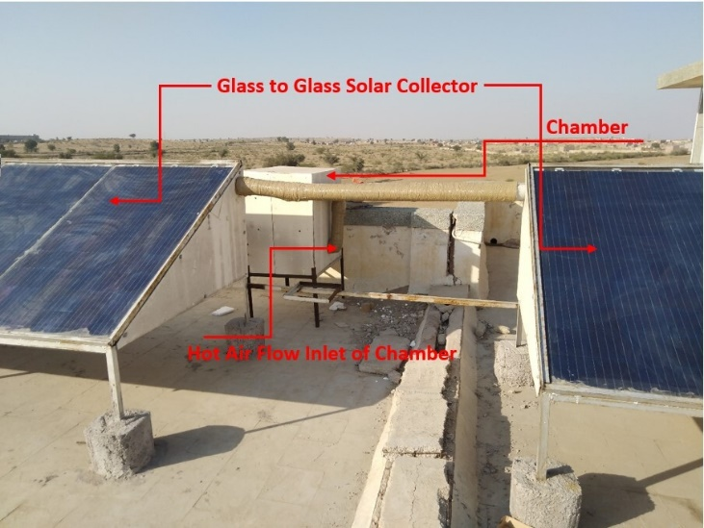  Fig. 1: Hot Air dryer of Glass to Glass Module | 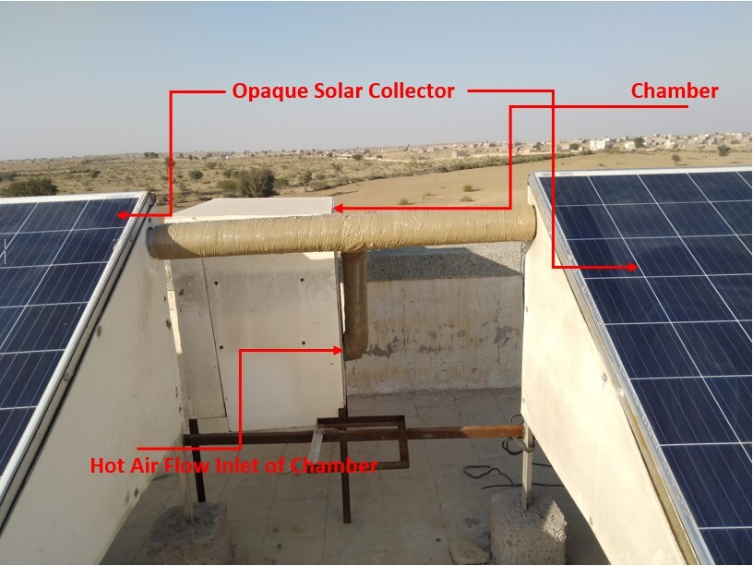  Fig. 2: Hot Air dryer of Opaque Module

The dryer basically consists of solar collector and drying chamber. Two different types of solar collectors were used for drying ginger samples namely, glass to glass and opaque. At the inlet of the duct ambient air having temperature range of 26 to 32 °C was passed through the solar collectors. The maximum air temperature inside the duct of glass to glass and opaque module was observed 68°C and 62°C respectively. Hot air collected by thermal energy transfer of solar collectors was fed into the dryer/box using insulated pipes .The dimensions of the chamber was 2.9 feet in length, 2 feet wide and 2.6 feet high. Inside the chamber the maximum temperature observed in glass to glass and opaque hot air dryer was 59°C and 54°C respectively.
2.3 Procedure
The experiments were performed during the month of November, 2020 in the climatic conditions of Bikaner (28.0229° N, 73.3119° E), India. 150 g weight of Ginger weighted on the electronic weighing machine having capacity 6 kg and least count 0.1g, and placed under OSD, hot air dryer of glass to glass and opaque module. Observations were recorded for all modes. The observation time interval for all modes was an hour. The two consecutive values of weighing machine directly gave the moisture evaporated during that time interval and was used in the calculations. The ginger samples were dried up to the safe storage moisture level of 13% to 14% (w.b.). Fresh ginger and dried ginger samples under OSD, hot air dryer glass to glass and opaque module are shown in Fig. 3.

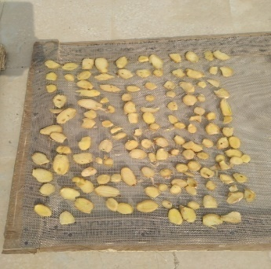  A | 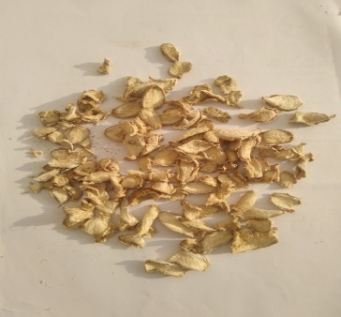  B | 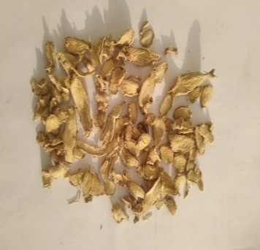  C | 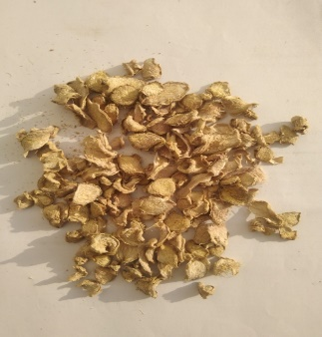  D
Fig. 3: Sample of (A) Fresh ginger, (B) Dried ginger under OSD (C) Dried ginger under glass to glass module (D) Dried ginger under opaque module.

- Mathematical Modeling
In terms of moisture removal rate, the experimental data obtained for the ginger was used for the drying kinetics of ginger. The moisture content data for both experimental modes were converted into moisture ratio and were used for various drying models. The moisture content data were converted into moisture ratios for both experimental modes and were used for different drying models as defined in Table 2.

Table 2. Mathematical models for thin layer drying
S.No. | Model name | Model | Reference
1 | Lewis Model | $$MR=exp\left(-kt\right)$$ | [24]
2 | Page Model | $$MR=exp\left(-kt^{n}\right)$$ | [25]
3. | Henderson And Pabis | $$MR=aexp\left(-kt\right)$$ | [26]

Note: k = drying constant (1/h); t = time (hrs); a = coefficient in the drying models, and n = no. of constants in drying models
- Calculation
The moisture removal rate is based on:
Moisture content on wet basis (% w.b.)
$M_{initial}=\frac{{(W}_{w}-W_{d})}{W_{w}}×100$ (1)

Where, $M_{initial}$ is the initial moisture content of ginger on d.b.%,$W_{w}$is the wet weight, and $W_{d}$is the dry weight of ginger in gm.

The moisture ratio of ginger during drying is estimated by:

$MR=\frac{M_{t}-M_{e}}{M_{i}-M_{e}}$ (2)
Where, $M_{t}$ = moisture content at ‘t’ drying time (%, dry basis); $M_{e}$= equilibrium moisture content, and $M_{i}$= initial moisture content (%, dry basis).

Statistical criteria, namely, coefficient of determination ($R^{2}$), reduced chi-square ($χ^{2}$), root mean square error (RMSE), and percent relative error for suitability of the best model described as

$R^{2}=\frac{{\left(\sum{M_{exp}M_{pre}}\right)}^{2}}{\sum{M_{exp}^{2}}\sum{M_{pre}^{2}}}$ (3)

$χ^{2}=\frac{\sum_{i=1}^{n}{{\left({MR}_{exp,i}-{MR}_{pre,i}\right)}^{2}}}{\left(N-n\right)}$ (4)
$MBE=\frac{\sum_{i=1}^{n}{\left({MR}_{exp,i}-{MR}_{pre,i}\right)}}{N}$ (5)
$RMSE=\sqrt{\frac{\sum_{i=1}^{n}{{\left({MR}_{exp,i}-{MR}_{pre,i}\right)}^{2}}}{N}}$ (6)
- Results and Discussion
The experimental data obtained for ginger drying under hot air drying in both glass to glass and opaque module and, open sun drying given in Table 3, 4 and 5 respectively.
Table 3. Experimental data for ginger in glass to glass module
Time, t (hrs) | 0 | 1 | 2 | 3 | 4 | 5 | 6 | 7 | 8
Moisture Content | 0.868 | 0.752 | 0.594 | 0.4513 | 0.2153 | 0.1267 | 0.0693 | 0.0173 | 0
Moisture Ratio | 1 | 0.8664 | 0.6843 | 0.52 | 0.2481 | 0.1459 | 0.0799 | 0.02 | 0
Table 4. Experimental data for ginger in opaque module
Time, t (hrs) | 0 | 1 | 2 | 3 | 4 | 5 | 6 | 7 | 8 | 9 | 10
Moisture Content | 0.865 | 0.8227 | 0.6813 | 0.5713 | 0.4853 | 0.366 | 0.2787 | 0.176 | 0.0973 | 0.036 | 0
Moisture Ratio | 1 | 0.9514 | 0.788 | 0.6608 | 0.5613 | 0.4233 | 0.3223 | 0.2035 | 0.1126 | 0.0416 | 0
Table 5. Experimental data for ginger in OSD
Time, t (hrs) | 0 | 1 | 2 | 3 | 4 | 5 | 6 | 7 | 8
Moisture Content | 0.8607 | 0.8527 | 0.7613 | 0.6793 | 0.5867 | 0.5433 | 0.4907 | 0.4427 | 0.3633
Moisture Ratio | 1 | 0.9907 | 0.8846 | 0.7893 | 0.6816 | 0.6313 | 0.5701 | 0.5143 | 0.4222
Time, t (hrs) | 9 | 10 | 11 | 12 | 13 | 14
Moisture Content | 0.2947 | 0.232 | 0.1433 | 0.0813 | 0.022 | 0
Moisture Ratio | 0.3424 | 0.2696 | 0.1665 | 0.0945 | 0.0256 | 0

The ginger samples were dried from initial moisture content of 86% (w.b.) to the safe storage moisture content of 13% to 14% (w.b.). Drying data of ginger samples were fitted to three thin layer drying models and the statistical parameters along with their constants was calculated by regression analysis using SOLVER computer program. The parameters are summarized in Table 6-8.
Table 6. Modeling of MR for thin layer drying of Ginger under Glass to Glass module
S. No. | Model name | k | N | a | R² | RMSE | χ² | MBE
1. | Lewis | 0.3009 | - | - | 0.970 | 0.10111 | 0.01168 | 0.00343
2. | Page | 0.1054 | 1.7962 | - | 0.996 | 0.02573 | 0.00698 | 0.00523
3. | Henderson And Pabis | 0.3276 | - | 1.1003 | 0.972 | 0.09158 | 0.01118 | 0.02095
Table 7. Modeling of MR for thin layer drying of Ginger under Opaque module
S. No. | Model name | k | N | a | R² | RMSE | χ² | MBE
1. | Lewis | 0.1929 | - | - | 0.976 | 0.1009 | 0.01133 | 0.00475
2. | Page | 0.0553 | 1.7415 | - | 0.997 | 0.0296 | 0.0011 | 0.00742
3. | Henderson And Pabis | 0.2162 | - | 1.1196 | 0.978 | 0.0873 | 0.00953 | 0.01603
Table 8. Modeling of MR for thin layer drying of Ginger under OSD
S. No. | Model name | k | N | a | R² | RMSE | χ² | MBE
1. | Lewis | 0.1232 | - | - | 0.974 | 0.1049 | 0.01185 | 0.0081
2. | Page | 0.0261 | 1.7474 | - | 0.994 | 0.0461 | 0.00248 | 0.0097
3. | Henderson And Pabis | 0.1407 | - | 1.1302 | 0.978 | 0.0923 | 0.0095 | 0.0132

The variation in term of moisture ratio for both modules with respect to drying time for the drying of ginger samples are shown in Fig 4-6.

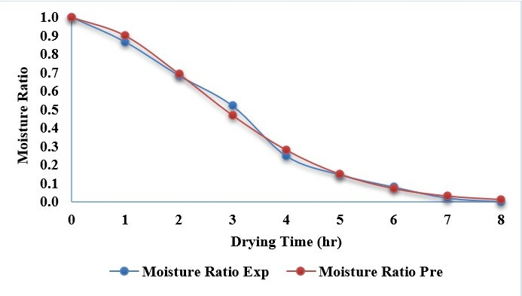
Fig. 4: Moisture ratio v/s drying time under glass to glass module
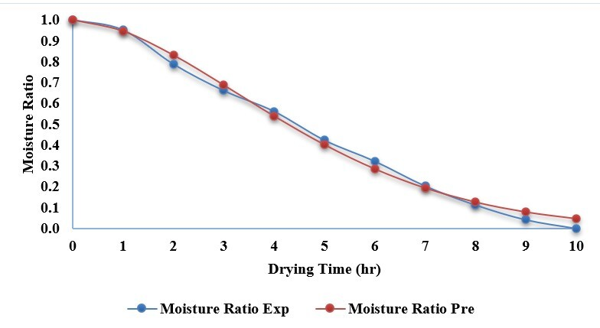
Fig. 5: Moisture ratio v/s drying time under opaque module

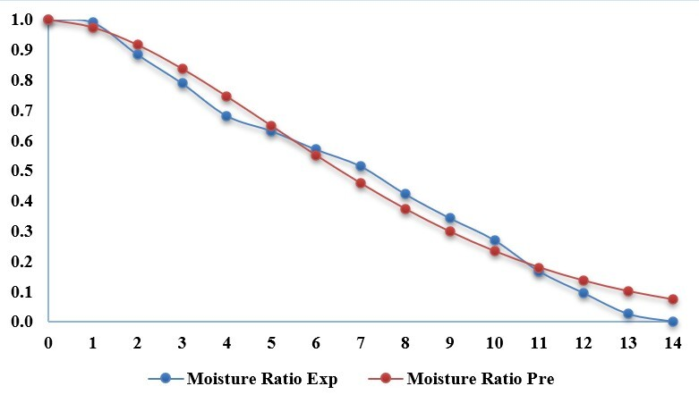
Fig. 6: Moisture ratio v/s drying time under OSD

From the Tables 6-8 it is observed that Page model with highest value of R² (0.996, 0.997 and 0.994) and lowest values of χ2 (0.00698,0.0011 and 0.00248), RMSE (0.02573, 0.0296 and 0.0461)and MBE (0.00523, 0.00742 and 0.0097)was found to be most suitable for ginger drying under hot air oven in glass to glass, opaque and open sun drying respectively among all the models investigated. Deshmukh et al. (2011) has also suggested the Page model for drying of ginger inside mixed mode solar cabinet drying [2].

Conclusion
Solar drying of ginger was studied in hot air dryer of glass to glass module, opaque module and OSD. Fresh ginger was dried from initial moisture content of 86 % (w.b.) to final moisture content of 13 to 14 % (w.b.). Hot air dryer of glass to glass module gives best result as time taken by hot air dryer of glass to glass module (8 hrs.) was less compared to opaque module (10 hrs.) and OSD (14 hrs.). The experimental data was validated to the predicted value and it was observed that moisture removing rate was quite similar. Drying behavior of ginger slices was analyzed using various mathematical models and found that the result obtained by Page model explains the drying behavior of ginger precisely with maximum values of coefficient of determination (R²) i.e. 0.996, 0.997 and 0.994 for hot air dryer of glass to glass module, opaque module and OSD respectively, and this model has minimum reduced chi-square, mean bias error and root mean square error.
Acknowledgment
The authors greatly acknowledge the financial support from the collaborative research scheme (CRS) Project ID 1-5763884671 from NPIU under TEQIP-III phase.

References

- Thorat, I. D., Mohapatra, D., Sutar, R. F., Kapdi, S. S., &Jagtap, D. D.. Mathematical modeling and experimental study on thin-layer vacuum drying of ginger (Zingiberofficinale R.) slices. Food and Bioprocess Technology, 5(4), (2012), 1379-1383.
- Deshmukh, A. W., Varma, M. N., Yoo, C. K., &Wasewar, K. L. Investigation of Solar drying of ginger (Zingiberofficinale): Emprical modelling, drying characteristics, and quality study. Chinese Journal of Engineering, 2014, (2014) 1-7.
- Muneer, T., Asif, M., &Munawwar, S., Sustainable production of solar electricity with particular reference to the Indian economy. Renewable and Sustainable Energy Reviews, 9(5), (2005) 444-473.
- Chavda, T. V., & Kumar, N., Solar dryers for high value agro products at Spreri. In Proceedings of the International Solar Food Processing Conference (2009), (pp. 205-226).
- Whitfield, D. E., Solar dryer systems and the internet: Important resources to improve food preparation. In Proceedings of International Conference on Solar Cooking, Kimberly, SouthAfrica., (2000)
- Amoah, R. E., Kalakandan, S., Wireko‐Manu, F. D., Oduro, I., Saalia, F. K., &Owusu, E.. The effect of vinegar and drying (Solar and Open Sun) on the microbiological quality of ginger (ZINGIBEROFFICINALE ROSCOE) rhizomes. Food Science & Nutrition, 8(11), (2020), 6112-6119.
- Rahman, H., Karuppaiyan, R., Kishore, K., &Denzongpa, R., Traditional practices of ginger cultivation in north east India. In Indian Journal of Traditional Knowledge, vol. 8, no. 1, (2009), pp. 23–28.
- Singh, K. K., Tiroutchelvame, D., & Patel, S., Drying characteristics of ginger flakes. In Proceedings of the 16th International Drying Symposium (IDS ’08), (2008), pp. 1383–1386, Hydrabad, India
- Deshmukh, A. W., Wasewar, K. L., &Verma, M. N., Solar drying of food materials as an alternative for energy crisis and environmental protection. International Journal of Chemical Sciences, 9(3), (2011), 1175-1182.
- Fudholi, A., &Hidayati, S., Modified Page Model for Solar Drying of Seaweed. International Journal of Advanced Science and Technology, 29(5), (2020), 7407-7413.
- Nukulwar, M. R., &Tungikar, V. B. . Evaluation of Drying Model and Quality Analysis of Turmeric Using Solar Thermal System. Applied Solar Energy, 56(4), (2020), 233-241.
- Nimnuan, P., &Nabnean, S., Experimental and simulated investigations of the performance of the solar greenhouse dryer for drying cassumunar ginger (ZingibercassumunarRoxb.). Case Studies in Thermal Engineering, 22, (2020), 100745
- Karthikeyan, A. K., &Murugavelh, S., Thin layer drying kinetics and exergy analysis of turmeric (Curcuma longa) in a mixed mode forced convection solar tunnel dryer. Renewable Energy, 128, (2018), 305-312.
- Sahdev, R. K., Kumar, M., &Dhingra, A. K., Development of empirical expression for thin layer groundnut drying under open sun and forced convection modes. Agricultural Engineering International: CIGR Journal, 19(4), (2018), 152-158
- Dhanushkodi, S., Wilson, V. H., &Sudhakar, K., Mathematical modeling of drying behavior of cashew in a solar biomass hybrid dryer. Resource-Efficient Technologies, 3(4), (2017), 359-364.
- Taghipour, M., Kakolaki, M. B., Zomorodian, A., &Nassiri, S. M., Determination of equilibrium isotherms and proper mathematical model for lime slices. Agricultural Engineering International: CIGR Journal, 18(1), (2016), 284-293.
- Mutuli, G. P., &Mbuge, D., Drying characteristics and energy requirement of drying cowpea leaves and jute mallow vegetables. Agricultural Engineering International: CIGR Journal, 17(4), (2015), 265-272.
- Mitrevski, V., Lutovska, M., Mijakovski, V., &Mijakovski, N., Statistical evaluation of thin-layer drying of banana. Journal of Hygienic Engineering and Design, 8, (2014), 145-152.
- Gharehbeglou, P., Askari, B., Rad, A. H., Hoseini, S. S., Pour, H. T., & Rad, A. H. E., Investigating of drying kinetics and mathematical modeling of turnip. Agricultural Engineering International: CIGR Journal, 16(3), (2014), 194-204.
- Bagheri, H., Arabhosseini, A., Kianmehr, M. H., &Chegini, G. R., Mathematical modeling of thin layer solar drying of tomato slices. Agricultural Engineering International: CIGR Journal, 15(1), (2013), 146-153.
- Mihindukulasuriya, S. D., &Jayasuriya, H. P., Drying of chilli in a combined infrared and hot air rotary dryer. Journal of food science and technology, 52(8), (2015), 4895-4904.
- Kaleta, A., Górnicki, K., Winiczenko, R., &Chojnacka, A., Evaluation of drying models of apple (var. Ligol) dried in a fluidized bed dryer. Energy Conversion and Management, 67, (2013), 179-185.
- Akpinar, E. K., Mathematical modelling of thin layer drying process under open sun of some aromatic plants. Journal of Food Engineering, 77(4), (2006), 864-870.
- Lewis, W. K., The rate of drying of solid materials. Industrial & Engineering Chemistry, 13(5), (1921), 427-432.
- Page, G. E. (1949). Factors Influencing the Maximum Rates of Air Drying Shelled Corn in Thin layers.
- Hendorson, S. M., Grain drying theory (I) temperature effect on drying coefficient. Journal of Agricultural Engineering Research, 6(3), (1961), 169-174.

